**Day 2:**

Data types in java with memory size.

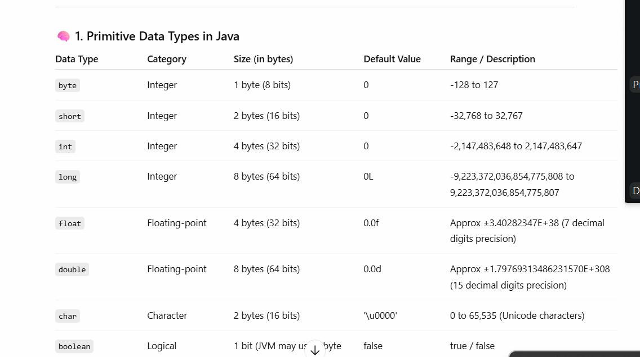

Operators : operator are symbol which help to do some operation on variables values.

1. Arithmetic operator : +, -, *, /, % (remainder)
2. Conditional operator : >, >=, <, <=, ==, !=
3. Logica operator : &&, ||, !
4. Increment and decrement operator ++, -- it increment / decrement by 1

Conditional statements

1. If statement

Syntax

If(condition) {

}

1. If else statement

Syntax

If(condition) {

}else {

}

1. If else if

Syntax

If(condition) {

}else if(condition) {

}else if(condition) {

}else {

}

1. Switch statement

Switch statement user or programmer can take the call which block need to execute base upon the value that particular block execute.

Syntax

switch(variabelname){

case label1: block1

break;

case label2: block2

break;

case label3: block3

break;

default : default block

break

}

Taking the value through keyboard in java.

1. Using Scanner class : Scanner is a pre defined class part of util package(like directory or folder). Package is a collection of classes.

First you need to create Scanner class object.

Syntax

Scanner obj = new Scanner(System.in);

Once we create the object. we need to import the util package.

This class provided lot of pre defined methods to scan the value

Like

obj.nextInt()

obj.nextLong()

obj.nextDouble();

obj.nextByte()

but not nextChar()

if we are planning to store more than once character then java provided one the pre defined class ie **String** class.

in Java String is pre defined class also known as reference or non primitive data types.

To create the String in java

String name = “Akash Kale”;

**Reference data types or not primitive data types :** it is use to store value as well as reference of another data types.

In Java 4 types of reference data types

1. array :
2. class
3. interface
4. enum

array : it is a type of reference data types. Which is use to store more than one value of same data types.

Syntax

Datatype variableName[];

Array use index concept to store the value. Index value start from 0.